23.14: Taking the origin at the center of the square, the symmetry means that the potential is the same at the two corners not occupied by the 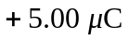 charges (The work done in moving to either corner from infinity is the same). But this also means that no net work is done is moving from one corner to the other.

